Piano for the Younger Beginner

The Musical Alphabet

- B-C-D-E-F-G
Notes and Rest Symbols (Based on 4 beats per measure)
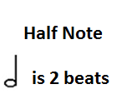
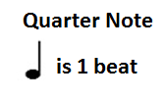

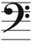
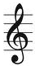
Right Hand -Treble Clef (G Clef) Left Hand -Bass Clef (F Clef)
Middle C Positions: Left Hand to the left of middle C and Right Hand to the right of middle
