BEGINNING PIANO

The Musical Alphabet : Start with A, B, C, D, E, F, G…start over again with A!

Notes and Rest Symbols (Based on 4 beats per measure)
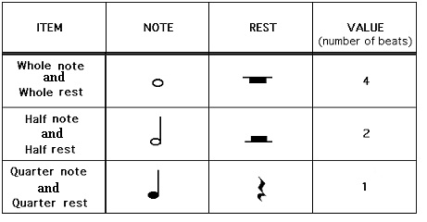
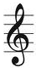

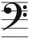
Right Hand -Treble Clef (G Clef)
Left Hand -Bass Clef (F Clef)
Time Signature = The Top number tells you how many beats are in each measure

Middle C Positions: Left Hand to the left of middle C and Right Hand to the right of middle
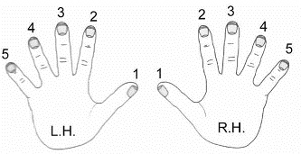
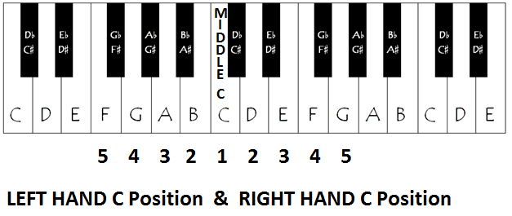

FINGER NUMBERS

